[**Visit My Github Profile**](https://github.com/panchalbhavya2210)

**Q - 1 : WHAT IS OS?**

ANS -> An operating system (OS) is the program that, after being initially loaded into the computer by a boot program, manages all of the other application programs in a computer. The application programs make use of the operating system by making requests for services through a defined application program interface (API). In addition, users can interact directly with the operating system through a user interface, such as a command-line interface (CLI) or a graphical UI (GUI).

**Q - 2 : EXPLAIN TYPES OF OS.**

ANS ->

**1**. **Batch Operating System –**

This type of operating system does not interact with the computer directly. There is an operator which takes similar jobs having the same requirement and group them into batches. It is the responsibility of the operator to sort jobs with similar needs.

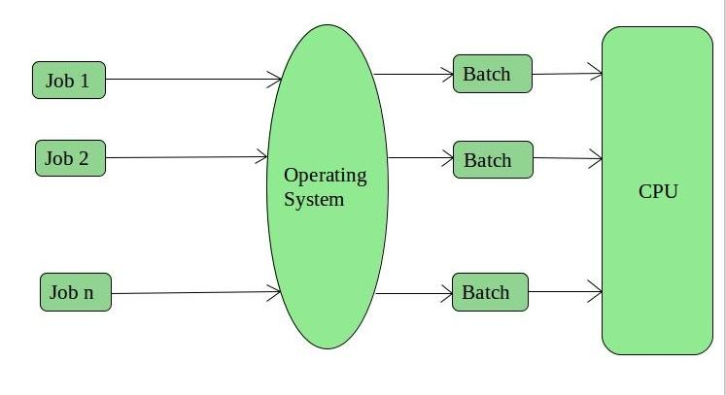

**Advantages of Batch Operating System:**

* It is very difficult to guess or know the time required for any job to complete. Processors of the batch systems know how long the job would be when it is in queue
* Multiple users can share the batch systems
* The idle time for the batch system is very less
* It is easy to manage large work repeatedly in batch systems

**Disadvantages of Batch Operating System:**

* The computer operators should be well known with batch systems
* Batch systems are hard to debug
* It is sometimes costly
* The other jobs will have to wait for an unknown time if any job fails

**Examples of Batch based Operating System:** Payroll System, Bank Statements, etc.

**2.** **Time-Sharing Operating Systems –**

Each task is given some time to execute so that all the tasks work smoothly. Each user gets the time of CPU as they use a single system. These systems are also known as Multitasking Systems. The task can be from a single user or different users also. The time that each task gets to execute is called quantum. After this time interval is over OS switches over to the next task.

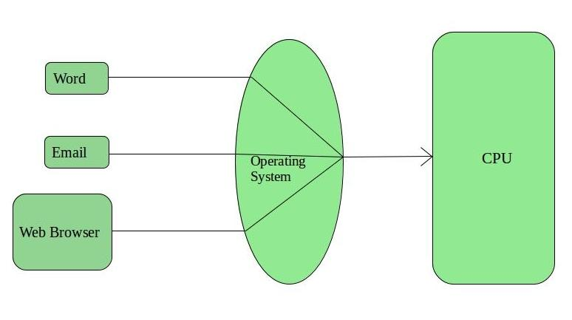

**Advantages of Time-Sharing OS:**

* Each task gets an equal opportunity
* Fewer chances of duplication of software
* CPU idle time can be reduced
* Disadvantages of Time-Sharing OS:

**Reliability problem**

* One must have to take care of the security and integrity of user programs and data
* Data communication problem

**Examples of Time-Sharing OSs are:** Multics, Unix, etc.

**3. Distributed Operating System –**

These types of the operating system is a recent advancement in the world of computer technology and are being widely accepted all over the world and, that too, with a great pace. Various autonomous interconnected computers communicate with each other using a shared communication network. Independent systems possess their own memory unit and CPU. These are referred to as loosely coupled systems or distributed systems. These system’s processors differ in size and function. The major benefit of working with these types of the operating system is that it is always possible that one user can access the files or software which are not actually present on his system but some other system connected within this network i.e., remote access is enabled within the devices connected in that network.

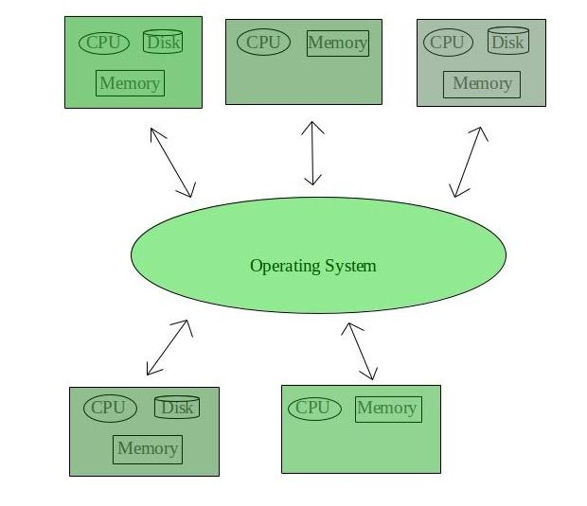

**Advantages of Distributed Operating System:**

* Failure of one will not affect the other network communication, as all systems are independent from each other
* Electronic mail increases the data exchange speed
* Since resources are being shared, computation is highly fast and durable
* Load on host computer reduces
* These systems are easily scalable as many systems can be easily added to the network
* Delay in data processing

**Disadvantage of Distributed Operating System:**

* Failure of the main network will stop the entire communication
* To establish distributed systems the language which is used are not well defined yet
* These types of systems are not readily available as they are very expensive. Not only that the underlying software is highly complex and not understood well yet

**Examples of Distributed Operating System are**- LOCUS, etc.

**4. Network Operating System –**

These systems run on a server and provide the capability to manage data, users, groups, security, applications, and other networking functions. These types of operating systems allow shared access of files, printers, security, applications, and other networking functions over a small private network. One more important aspect of Network Operating Systems is that all the users are well aware of the underlying configuration, of all other users within the network, their individual connections, etc. and that’s why these computers are popularly known as tightly coupled systems.

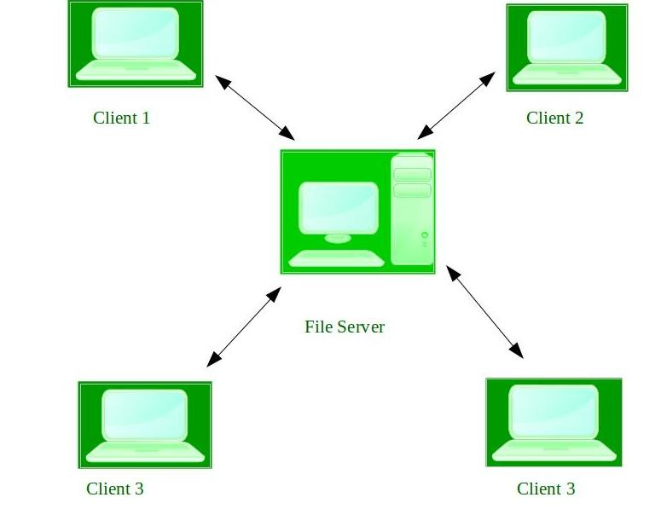

**Advantages of Network Operating System:**

* Highly stable centralized servers
* Security concerns are handled through servers
* New technologies and hardware up-gradation are easily integrated into the system
* Server access is possible remotely from different locations and types of systems

**Disadvantages of Network Operating System:**

* Servers are costly
* User has to depend on a central location for most operations
* Maintenance and updates are required regularly

**Examples of Network Operating System are:** Microsoft Windows Server 2003, Microsoft Windows Server 2008, UNIX, Linux, Mac OS X, Novell NetWare, and BSD, etc.

**5. Real-Time Operating System –**

These types of OSs serve real-time systems. The time interval required to process and respond to inputs is very small. This time interval is called response time.

Real-time systems are used when there are time requirements that are very strict like missile systems, air traffic control systems, robots, etc.

Two types of Real-Time Operating System which are as follows:

**Hard Real-Time Systems:**

These OSs are meant for applications where time constraints are very strict and even the shortest possible delay is not acceptable. These systems are built for saving life like automatic parachutes or airbags which are required to be readily available in case of any accident. Virtual memory is rarely found in these systems.

**Soft Real-Time Systems:**

These OSs are for applications where for time-constraint is less strict.

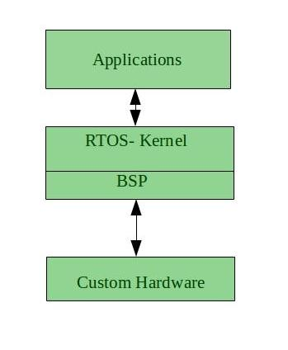

**Advantages of RTOS:**

**Maximum Consumption**: Maximum utilization of devices and system, thus more output from all the resources

**Task Shifting**: The time assigned for shifting tasks in these systems are very less. For example, in older systems, it takes about 10 microseconds in shifting one task to another, and in the latest systems, it takes 3 microseconds.

**Focus on Application**: Focus on running applications and less importance to applications which are in the queue.

**Real-time operating system in the embedded system**: Since the size of programs are small, RTOS can also be used in embedded systems like in transport and others.

**Error Free**: These types of systems are error-free.

**Memory Allocation**: Memory allocation is best managed in these types of systems.

**Disadvantages of RTOS:**

**Limited Tasks:** Very few tasks run at the same time and their concentration is very less on few applications to avoid errors.

**Use heavy system resources**: Sometimes the system resources are not so good and they are expensive as well.

**Complex Algorithms**: The algorithms are very complex and difficult for the designer to write on.

**Device driver and interrupt signals**: It needs specific device drivers and interrupts signals to respond earliest to interrupts.

**Thread Priority**: It is not good to set thread priority as these systems are very less prone to switching tasks.

**Examples of Real-Time Operating Systems are:** Scientific experiments, medical imaging systems, industrial control systems, weapon systems, robots, air traffic control systems, etc.

**Q - 3 :EXPLAIN THE STRUCTURE OF OS &**

**EXPLAIN COMPONENTS OF OS IN DETAIL.**

ANS ->

**Simple Structure :**

There are many operating systems that have a rather simple structure. These started as small systems and rapidly expanded much further than their scope. A common example of this is MS-DOS. It was designed simply for a niche amount for people. There was no indication that it would become so popular.

An image to illustrate the structure of MS-DOS is as follows −

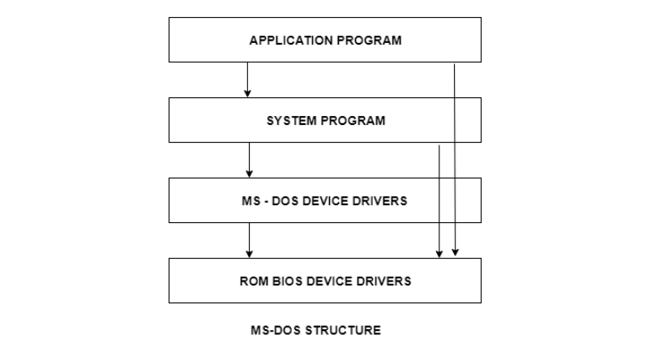

It is better that operating systems have a modular structure, unlike MS-DOS. That would lead to greater control over the computer system and its various applications. The modular structure would also allow the programmers to hide information as required and implement internal routines as they see fit without changing the outer specifications.

**Layered Structure :**

One way to achieve modularity in the operating system is the layered approach. In this, the bottom layer is the hardware and the topmost layer is the user interface.

An image demonstrating the layered approach is as follows −

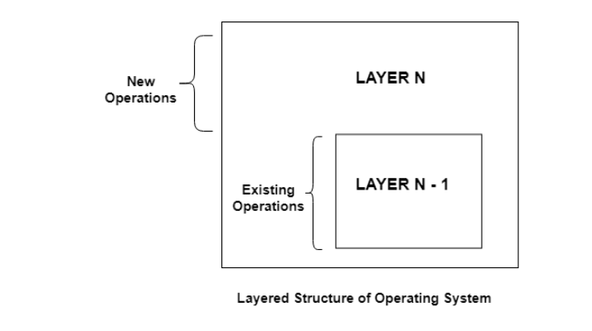

As seen from the image, each upper layer is built on the bottom layer. All the layers hide some structures, operations etc from their upper layers.

One problem with the layered structure is that each layer needs to be carefully defined. This is necessary because the upper layers can only use the functionalities of the layers below them.

-> **Component of OS :**

An operating system is a large and complex system that can only be created by partitioning into small parts. These pieces should be a well-defined part of the system, carefully defining inputs, outputs, and functions.

* Process Management
* File Management
* Network Management
* Main Memory Management
* Secondary Storage Management
* I/O Device Management
* Security Management
* Command Interpreter System

**Process Management :**

The process management component is a procedure for managing many processes running simultaneously on the operating system. Every running software application program has one or more processes associated with them.

For example, when you use a search engine like Chrome, there is a process running for that browser program.

Process management keeps processes running efficiently. It also uses memory allocated to them and shutting them down when needed.

The execution of a process must be sequential so, at least one instruction should be executed on behalf of the process.

**Functions of process management**

Here are the following functions of process management in the operating system, such as:

* Process creation and deletion.
* Suspension and resumption.
* Synchronization process
* Communication process

**File Management :**

A file is a set of related information defined by its creator. It commonly represents programs (both source and object forms) and data. Data files can be alphabetic, numeric, or alphanumeric.

Components of Operating System

Function of file management

The operating system has the following important activities in connection with file management:

* File and directory creation and deletion.
* For manipulating files and directories.
* Mapping files onto secondary storage.
* Backup files on stable storage media.

**Network Management**

Network management is the process of administering and managing computer networks. It includes performance management, provisioning of networks, fault analysis, and maintaining the quality of service.

Components of Operating System

A distributed system is a collection of computers or processors that never share their memory and clock. In this type of system, all the processors have their local memory, and the processors communicate with each other using different communication cables, such as fibre optics or telephone lines.

The computers in the network are connected through a communication network, which can configure in many different ways. The network can fully or partially connect in network management, which helps users design routing and connection strategies that overcome connection and security issues.

**Functions of Network management**

Network management provides the following functions, such as:

* Distributed systems help you to various computing resources in size and function. They may involve minicomputers, microprocessors, and many general-purpose computer systems.
* A distributed system also offers the user access to the various resources the network shares.
* It helps to access shared resources that help computation to speed up or offers data availability and reliability.

**Main Memory management**

Main memory is a large array of storage or bytes, which has an address. The memory management process is conducted by using a sequence of reads or writes of specific memory addresses.

It should be mapped to absolute addresses and loaded inside the memory to execute a program. The selection of a memory management method depends on several factors.

However, it is mainly based on the hardware design of the system. Each algorithm requires corresponding hardware support. Main memory offers fast storage that can be accessed directly by the CPU. It is costly and hence has a lower storage capacity. However, for a program to be executed, it must be in the main memory.

Components of Operating System

Functions of Memory management

An Operating System performs the following functions for Memory Management in the operating system:

* It helps you to keep track of primary memory.
* Determine what part of it are in use by whom, what part is not in use.
* In a multiprogramming system, the OS decides which process will get memory and how much.
* Allocates the memory when a process requests.
* It also de-allocates the memory when a process no longer requires or has been terminated.

**Secondary-Storage Management:**

The most important task of a computer system is to execute programs. These programs help you to access the data from the main memory during execution. This memory of the computer is very small to store all data and programs permanently. The computer system offers secondary storage to back up the main memory.

Components of Operating System

Today modern computers use hard drives/SSD as the primary storage of both programs and data. However, the secondary storage management also works with storage devices, such as USB flash drives and CD/DVD drives. Programs like assemblers and compilers are stored on the disk until it is loaded into memory, and then use the disk is used as a source and destination for processing.

Functions of Secondary storage management

Here are some major functions of secondary storage management in the operating system:

* Storage allocation
* Free space management
* Disk scheduling

**I/O Device Management**

One of the important use of an operating system that helps to hide the variations of specific hardware devices from the user.

Components of Operating System

Functions of I/O management

The I/O management system offers the following functions, such as:

* It offers a buffer caching system
* It provides general device driver code
* It provides drivers for particular hardware devices.
* I/O helps you to know the individualities of a specific device.

**Security Management**

The various processes in an operating system need to be secured from other activities. Therefore, various mechanisms can ensure those processes that want to operate files, memory CPU, and other hardware resources should have proper authorization from the operating system.

Security refers to a mechanism for controlling the access of programs, processes, or users to the resources defined by computer controls to be imposed, together with some means of enforcement.

Components of Operating System

For example, memory addressing hardware helps to confirm that a process can be executed within its own address space. The time ensures that no process has control of the CPU without renouncing it. Lastly, no process is allowed to do its own I/O to protect, which helps you to keep the integrity of the various peripheral devices.

Security can improve reliability by detecting latent errors at the interfaces between component subsystems. Early detection of interface errors can prevent the foulness of a healthy subsystem by a malfunctioning subsystem. An unprotected resource cannot misuse by an unauthorized or incompetent user.

**Command Interpreter System**

One of the most important components of an operating system is its command interpreter. The command interpreter is the primary interface between the user and the rest of the system.

Components of Operating System

Many commands are given to the operating system by control statements. A program that reads and interprets control statements is automatically executed when a new job is started in a batch system or a user logs in to a time-shared system. This program is variously called.

* The control card interpreter,
* The command-line interpreter,
* The shell (in UNIX), and so on.

**Q - 4 : EXPLAIN SERVICES OF OS.**

ANS -> An Operating System provides services to both the users and to the programs.

It provides programs an environment to execute.

It provides users the services to execute the programs in a convenient manner.

Following are a few common services provided by an operating system −

* Program execution
* I/O operations
* File System manipulation
* Communication
* Error Detection
* Resource Allocation
* Protection

**Program execution**

Operating systems handle many kinds of activities from user programs to system programs like printer spooler, name servers, file server, etc. Each of these activities is encapsulated as a process.

A process includes the complete execution context (code to execute, data to manipulate, registers, OS resources in use). Following are the major activities of an operating system with respect to program management −

* Loads a program into memory.
* Executes the program.
* Handles program's execution.
* Provides a mechanism for process synchronization.
* Provides a mechanism for process communication.
* Provides a mechanism for deadlock handling.

**I/O Operation**

An I/O subsystem comprises of I/O devices and their corresponding driver software. Drivers hide the peculiarities of specific hardware devices from the users.

An Operating System manages the communication between user and device drivers.

* I/O operation means read or write operation with any file or any specific I/O device.
* Operating system provides the access to the required I/O device when required.

**File system manipulation**

A file represents a collection of related information. Computers can store files on the disk (secondary storage), for long-term storage purpose. Examples of storage media include magnetic tape, magnetic disk and optical disk drives like CD, DVD. Each of these media has its own properties like speed, capacity, data transfer rate and data access methods.

A file system is normally organized into directories for easy navigation and usage. These directories may contain files and other directions. Following are the major activities of an operating system with respect to file management −

* Program needs to read a file or write a file.
* The operating system gives the permission to the program for operation on file.
* Permission varies from read-only, read-write, denied and so on.
* Operating System provides an interface to the user to create/delete files.
* Operating System provides an interface to the user to create/delete directories.
* Operating System provides an interface to create the backup of file system.

**Communication**

In case of distributed systems which are a collection of processors that do not share memory, peripheral devices, or a clock, the operating system manages communications between all the processes. Multiple processes communicate with one another through communication lines in the network.

The OS handles routing and connection strategies, and the problems of contention and security. Following are the major activities of an operating system with respect to communication −

* Two processes often require data to be transferred between them
* Both the processes can be on one computer or on different computers, but are connected through a computer network.
* Communication may be implemented by two methods, either by Shared Memory or by Message Passing.

**Error handling**

Errors can occur anytime and anywhere. An error may occur in CPU, in I/O devices or in the memory hardware. Following are the major activities of an operating system with respect to error handling −

* The OS constantly checks for possible errors.
* The OS takes an appropriate action to ensure correct and consistent computing.

**Resource Management**

In case of multi-user or multi-tasking environment, resources such as main memory, CPU cycles and files storage are to be allocated to each user or job. Following are the major activities of an operating system with respect to resource management −

* The OS manages all kinds of resources using schedulers.
* CPU scheduling algorithms are used for better utilization of CPU.

**Protection**

Considering a computer system having multiple users and concurrent execution of multiple processes, the various processes must be protected from each other's activities.

Protection refers to a mechanism or a way to control the access of programs, processes, or users to the resources defined by a computer system. Following are the major activities of an operating system with respect to protection −

* The OS ensures that all access to system resources is controlled.
* The OS ensures that external I/O devices are protected from invalid access attempts.
* The OS provides authentication features for each user by means of passwords.

**Q - 5 : EXPLAIN SYSTEM CALL WITH EXAMPLE.**

ANS -> In computing, a system call is the programmatic way in which a computer program requests a service from the kernel of the operating system it is executed on. A system call is a way for programs to interact with the operating system. A computer program makes a system call when it makes a request to the operating system’s kernel. System call provides the services of the operating system to the user programs via Application Program Interface(API). It provides an interface between a process and operating system to allow user-level processes to request services of the operating system. System calls are the only entry points into the kernel system. All programs needing resources must use system calls.

**Services Provided by System Calls** :

* Process creation and management
* Main memory management
* File Access, Directory and File system management
* Device handling(I/O)
* Protection
* Networking, etc.

**Types of System Calls :** There are 5 different categories of system calls –

**Process control**: end, abort, create, terminate, allocate and free memory.

**File management:** create, open, close, delete, read file etc.

**Device management**

**Information maintenance**

**Communication**

**Protection**

**Examples of Windows and Unix System Calls –**

|  | UNIX | WINDOWS |
| --- | --- | --- |
| **Process Control** | fork()  exit()  wait() | CreateProcess()  ExitProcess()  WaitForSingleObject() |
| **File Manipulation** | open()  read()  write()  close() | CreateFile()  ReadFile()  WriteFile()  CloseHandle() |
| **Device Manipulation** | ioctl()  read()  write() | SetConsoleMode()  ReadConsole()  WriteConsole() |
| **Information Maintenance** | getpid()  alarm()  sleep() | GetCurrentProcessID()  SetTimer()  Sleep() |
| **Communication** | pipe()  shmget()  mmap() | CreatePipe()  CreateFileMapping()  MapViewOfFile() |
| **Protection** | chmod()  umask()  chown() | SetFileSecurity()  InitlializeSecurityDescriptor()  SetSecurityDescriptorGroup() |

**Q - 6 : SHORT NOTE ON SYSTEM PROGRAM.**

ANS -> System Programming can be defined as the act of building Systems Software using System Programming Languages.

System Programs can be divided into these categories :

**File Management** –

A file is a collection of specific information stored in the memory of a computer system. File management is defined as the process of manipulating files in the computer system, its management includes the process of creating, modifying and deleting files.

* It helps to create new files in the computer system and placing them at specific locations.
* It helps in easily and quickly locating these files in the computer system.
* It makes the process of sharing files among different users very easy and user-friendly.
* It helps to store files in separate folders known as directories.
* These directories help users to search files quickly or to manage files according to their types of uses.
* It helps users to modify the data of files or to modify the name of files in directories.

**Status Information –**

Information like date, time amount of available memory, or disk space is asked by some users. Others providing detailed performance, logging, and debugging information which is more complex. All this information is formatted and displayed on output devices or printed. Terminal or other output devices or files or a window of GUI is used for showing the output of programs.

**File Modification –**

For modifying the contents of files we use this. For Files stored on disks or other storage devices, we used different types of editors. For searching contents of files or perform transformations of files we use special commands.

**Programming-Language support –**

For common programming languages, we use Compilers, Assemblers, Debuggers, and interpreters which are already provided to users. It provides all support to users. We can run any programming language. All languages of importance are already provided.

**Program Loading and Execution –**

When the program is ready after Assembling and compilation, it must be loaded into memory for execution. A loader is part of an operating system that is responsible for loading programs and libraries. It is one of the essential stages for starting a program. Loaders, relocatable loaders, linkage editors, and Overlay loaders are provided by the system.

**Communications** –

Virtual connections among processes, users, and computer systems are provided by programs. Users can send messages to another user on their screen, User can send e-mail, browsing on web pages, remote login, the transformation of files from one user to another.

Some examples of system program in O.S. are –

* Windows 10
* Mac OS X
* Ubuntu
* Linux
* Unix
* Android
* Anti-virus
* Disk formatting
* Computer language translators

**Q - 7 : EXPLAIN CONCEPT OF VIRTUAL MACHINE.**

ANS -> Virtual Machine abstracts the hardware of our personal computer such as CPU, disk drives, memory, NIC (Network Interface Card) etc, into many different execution environments as per our requirements, hence giving us a feel that each execution environment is a single computer. For example, VirtualBox.

When we run different processes on an operating system, it creates an illusion that each process is running on a different processor having its own virtual memory, with the help of CPU scheduling and virtual-memory techniques. There are additional features of a process that cannot be provided by the hardware alone like system calls and a file system. The virtual machine approach does not provide these additional functionalities but it only provides an interface that is same as basic hardware. Each process is provided with a virtual copy of the underlying computer system.

We can create a virtual machine for several reasons, all of which are fundamentally related to the ability to share the same basic hardware yet can also support different execution environments, i.e., different operating systems simultaneously.

The main drawback with the virtual-machine approach involves disk systems. Let us suppose that the physical machine has only three disk drives but wants to support seven virtual machines. Obviously, it cannot allocate a disk drive to each virtual machine, because virtual-machine software itself will need substantial disk space to provide virtual memory and spooling. The solution is to provide virtual disks.

Users are thus given their own virtual machines. After which they can run any of the operating systems or software packages that are available on the underlying machine. The virtual-machine software is concerned with multi-programming multiple virtual machines onto a physical machine, but it does not need to consider any user-support software. This arrangement can provide a useful way to divide the problem of designing a multi-user interactive system, into two smaller pieces.

**Advantages**:

* There are no protection problems because each virtual machine is completely isolated from all other virtual machines.
* Virtual machine can provide an instruction set architecture that differs from real computers.
* Easy maintenance, availability and convenient recovery.

**Disadvantages**:

* When multiple virtual machines are simultaneously running on a host computer, one virtual machine can be affected by other running virtual machines, depending on the workload.
* Virtual machines are not as efficient as a real one when accessing the hardware.

*"****DON'T REMEMBER IT ,***

***UNDERSTAND IT."***